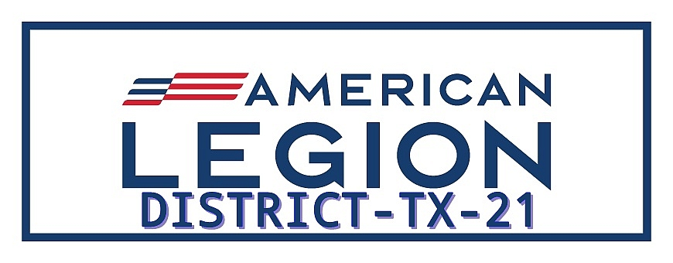

DISTRICT 21 EXECUTIVE COMMITTEE MEETING
Minutes for Executive Committee Meeting
June 3, 2026
6:00PM to 7:00PM

A. Called Meeting to order by Commander Don Gray at 6:00pm.
1. Opening Prayer given by Chaplain George McHorse.
2. Pledge of Allegiance led by Commander.

B. Quorum Count: Sergeant -at-Arms—Mike Wheeler Roll Call.
Attending:
Commander Don Gray
Chaplain George McHorse
Sgt. At Arms Mike Wheeler
Rick Greenfield
Dennis Fedak
Larry Miller
David McWilliams
Jeff Meurer
Justin Rogers
Carl Luckenbach
Kyle Stanbro

C. Approval to forego reading Minutes from January Meeting:
Motion –Justin Rogers
Second---Larry Miller
Approved—YES

D. District Officer/Committee Reports:
1.Vice Commander---Veronica Garcia—Excused Absence
2. Finance Officer—Robert Garcia—Excused Absence
3. Adjutant Report—Susan Junker--Excused Absence
4. Veteran Service Officer—Dennis Birchall—Excused Absence
5. Americanism Chairperson—Rick Greenfield—Excused Absence
6. National Defense Chairperson—John Quigley—Excused Absence
7. Boys State/Oratorical Chairperson—Larry Miller—Discussed 2026 program and resolution to move sole oversight of Boys State to Department of Texas Americanism Commission. Discussed t-Shirts for $10 to give boys.
8. Legislative/VA&R Chairperson—Paul Wade—Excused Absence

- Unfinished/ Old Business:
- Membership Goals—Currently at 97% of goal
- Reports from Posts—Post Data, CPR’s, Post Certification. Reminder to complete.
Post 410 parade for Memorial Day and Member check program.
Post 572 golf tournament successful.
Post 437 placed flags at cemetery. Had flag retirement ceremony.
Post 208 Flags and wreath at courthouse.
Post 157 had parade.
- Mid-Winter DEC—Austin—January 29-February 1, 2026. Nothing exciting to report.
- District Convention—Bandera Post 157, March 20-22, 2026. Very successful and well attended. Survey favorable.
- Division 4 Convention—Snyder- May 1-3, 2026. Election held and Jeff Meurer will be Vice Commander for Division 4-2026-27.

- New Business
- Department Convention—Austin—July 7-12, 2026. Don encouraged all to attend and send Post Everlasting list to him.
- Training—New Member Orientation training to start in 2026. Zone Commanders led. Will establish in September.
- District Legion College---October 2026 in San Angelo—Kristie Young will set up and lead.
- Posts reports---activity, programs, membership, etc. Continue Post activity and membership.
- Announcements/For the Good of the Post.
District 21 convention in planning stages with Llano hosting. More to come.
H. Executive Session (If Necessary)

I. Meeting Closing
- Closing Prayer—George McHorse.

J. Adjourn Meeting Motion made by Justin Rogers and seconded by Jeff Meurer. Passed.

Approved By:

Don Gray
Commander District 21

