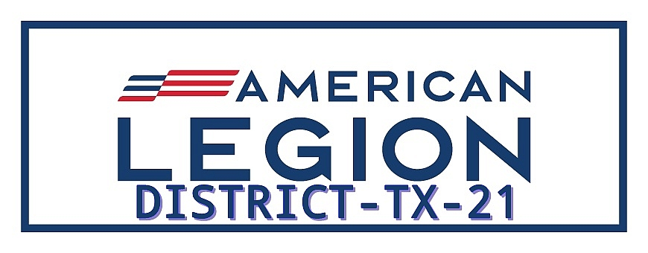

DISTRICT 21 EXECUTIVE COMMITTEE MEETING
Agenda for Executive Committee Meeting
October 7, 2026
6:00PM to 7:00PM

A. Convene Meeting.
1. Opening Prayer—Caps Removed-George McHorse
2. Pledge of Allegiance—Caps Removed
B. Quorum Count: Sergeant -at-Arms—Mike Wheeler

C. Approval of the Minutes from Meeting in August 2026.

D. District Officer/Committee Reports:
1.Vice Commander---Veronica Garcia
2. Finance Officer—Robert Garcia
3. Adjutant Report—Susan Junker
4. Veteran Service Officer—Dennis Birchall
5. Boys State/Oratorical Chairperson—Larry Miller
Motion to accept reports as given.

- Unfinished/ Old Business:
- Status of Flag stand and Flag cover for District.
- Report on National Convention—Jeff Meurer
- Report on Fall DEC—Don Gray

- New Business
- Membership— Post goals for 2027. How will Post accomplish.
- Training—needs of Post members. (Basic Training) (Zone Training) (District Legion College).
- Mid-Winter DEC---January 19-February 24, 2027.
- District Convention—Llano Post, March 5-7, 2027.
- Division Convention—San Angelo—April 30-May 2, 2027.
- Department Convention—Austin—July 6-11, 2027.

- Announcements/Requests for the Good of the District.

H. Executive Session (If Necessary)

I. Meeting Closing
- Closing Prayer—Caps Removed—Chaplain George McHorse

J. Adjourn Meeting

Approved By:

Don Gray
Commander District 21

